Thomas Courtney

3175353  UON

PHYS2170: Investigation of the Hall Effect in Semiconductors

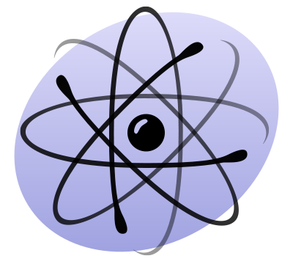

Contents

Abstract 2

Introduction 2

Procedure 4

Results 5

Discussion 6

Inaccuracy 6

Data Analysis 7

Conclusion 8

Appendix 9

Calculations 9

Bibliography 10

# Abstract

This report details the observation of the Hall effect in two germanium samples, 3369 and 3375. Hall Voltages were recorded for changing magnetic fields and used to calculate the hall coefficient, carrier type, density and carrier mobility of each material. Sample 3369 was found to be a p-type semiconductor and its carrier density was 3.03x1013 ± **XX** cm-3. Sample 3375 was found to be an n-type semiconductor with a carrier density of 3.12 x1013 ± **XX** cm-3.

# 

# Introduction

The Hall Effect is phenomenon where in a magnetic field is applied perpendicular to a current passing through a conductor. This in turn generates a force on the charge carriers in the conductor deflecting them in the axis perpendicular to both the magnetic field and current direction (see Figure 1.) The deflection of the carriers creates an accumulation of charges in one place and hence potential difference is created. This potential difference is the “hall voltage”.

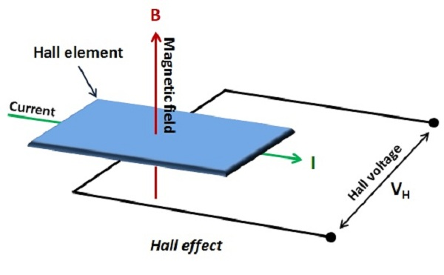

Figure : Magnetic field and current applied to a conductor generating a hall voltage (source: dangerousprototypes.com)

By knowing the direction of the magnetic field and current, the direction of the force acting on a charge carrier can be determined (See figure 2). This information in combination with knowing the orientation of the voltmeter terminals measuring the hall voltage can be used to figure out the majority carrier “type” of the sample.

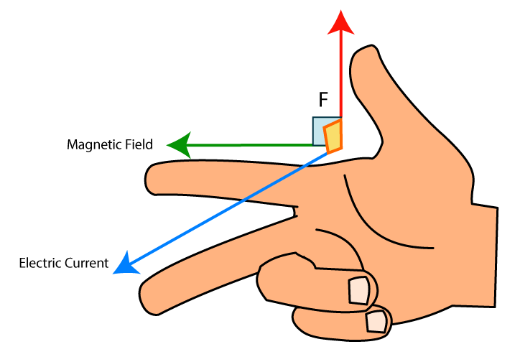

Figure : Right-hand rule, indicating the direction of force acting on a positive charge carrier.

If the magnitude of the magnetic field is increased the hall voltage will either increase or decrease relative to the initial reading. This indicates which terminal charges are accumulating on. For example, if the voltage is negative and increasing in the negative direction then negative charges are accumulating at the positive terminal OR positive charges are accumulating at the negative terminal of the voltmeter. Say that things are oriented as in Figure 3. By using the right-hand-rule you can determine which of these two cases is occurring and hence what the majority charge carrier is.

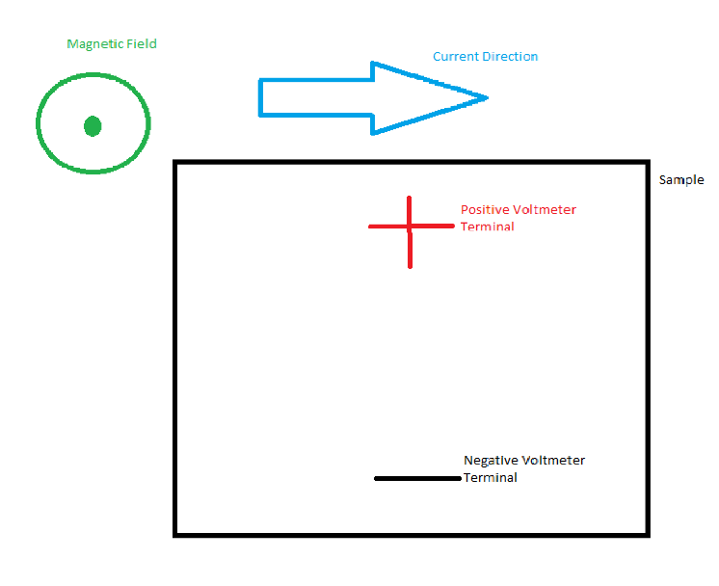

Figure : Conducting material experiencing hall effect due to current and magnetic field.

Applying the right-hand-rule to figure 3 according to the behaviour described,

If the majority of charges accumulate on the positive terminal of the voltmeter (and hence the voltage is positive) then the

# Procedure

Using the four-probe method on a 6x8x0.05cm wafer of germanium allowed the change in resistance of the material be calculated as it cooled. The wafer was heated in a small oven and temperature was measured with a probe thermometer (see Figure 4).

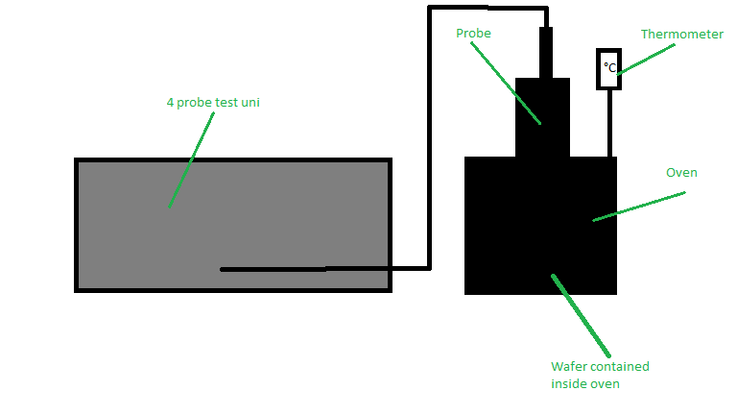

Figure 4: Apparatus for four-probe testing of germanium wafer including test unit, oven and thermometer.

The germanium wafer was heated to 170 °C and then allowed to cool. Voltage readings were taken every 5 °C until the wafer reached 50 °C and then voltage readings were taken every 2 °C until the wafer reached 34 °C.

Using the voltage/temperature data pairs at each point the resistance of the wafer could be calculated and hence the conductivity of the material (See Appendix – Calculations). Applying the natural logarithm to the calculated resistance values and plotting them against the inverse of the matching temperature value gives a near linear plot. Fitting the data to a linear plot and taking the plots gradient gives the energy gap of the germanium wafer (See Figure 5).

# Results

Figure 5: Natural log of resistance of a cooling germanium wafer plotted against the inverse of its temperature.

Table : The gradient and energy gap determined using the experimental and data for a germanium wafer. Based on Figure 5. For energy gap calculation see Appendix -Calculation **1**.

|  |  |  |
| --- | --- | --- |
| **Data Source** | **Gradient** | **Energy Gap (eV)** |
| Experimental | 2998.8 | 0.5160 |
| Calculated | 2570.9 | 0.4429 |

# Discussion

## Inaccuracy

This experiment was conducted affected by several inaccuracies. The instruments used all had associated inaccuracies, for example the thermometer±1 °C. The four-probe method assumes a number of parameters are correctly setup such as alignment of the probes and perfect contact of the probes. These things are easily executed imperfectly due to human error additionally the instrument has an associated inaccuracy of ±0.1% and ±0.1mV for the voltmeter and ±0.25% and ±0.1mA for the current generator.

In the calculation phase as the results did not produce an exactly linear plot (see Figure 5) the data was linearly fitted. The approximation affected the basis of the calculation to obtain the energy gap of the germanium sample (see Appendix- Calculations 1). Unsurprisingly the results obtained, 0.5160 eV for experimental data and 0.4429 eV for calculated data, were some 20 – 40% different to the actual value for the band gap of germanium which is 0.66 eV [1]. Due to imperfect data however, this compromise is necessary.

There was a single outlier in the measured data (see Figure 5) which can be attributed to a displacement of the instrumentation causing imperfect contact with the sample. It also could have been cause random event in the hardware.

The four-probe method, though imperfect, is still superior to other method of measuring the resistivity of a material. Because the millivoltmeter is applied in parallel with the sample (see Figure 6) and it has a high impedance (10MΩ) it does not draw any current out of the circuit and affect the calculation of the resistance of the material. This calculation is based on Ohm’s law.

$$R=\frac{V}{I}$$

If the method of soldering wires onto the sample, the associated resistivity of the soldering and wires would contribute to the series resistance calculated by the probe that is mean to represent that of the sample. This in turn would generate inaccurate data, more so than data generated by the four-probe method. Comparatively the series resistance contributed by the four-probe method is very small.

The experimental data’s qualities could be improved by an increased number of trials and greater care to implement the four-probe method’s setup.

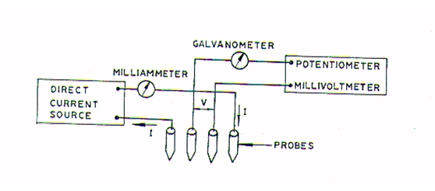

Figure 6: Four-probe method’s individual contacts diagram.

## Data Analysis

The near-linear sections of the plot in Figure 5 which are positively sloped indicate that as the sample cooled the resistance of the sample rose. This implies that the materials conductivity increased with temperature.

$$σ=\frac{1}{ρ}$$

$$Where ρ=resistvity and σ=conductivity.$$

The reason that the germanium’s conductivity rose as the sample was heated is that the thermal energy is transferred to the electrons and agitates them. If the agitation is sufficiently large the electrons may be pushed across the band gap and into the conduction band. This generates a hole in the valence band (p-type) which is a positive charge carrier. It also creates an extra electron in the conduction band (n-type) which is a negative charge carrier. This is called *intrinsic* conduction.

Figure 7: Ideal plot of change in conductivity due to temperature

In Figure 7 above, which is an ideally linear shaped dummy plot, the flat areas of the plot indicate regions of *extrinsic* conductivity, as temperature has no affect on this region. Therefore, for sufficiently small temperatures insufficient energy is supplied to electrons to cross the band gap. This is the conductive behaviour of the material without extra energy and it can be improved via doping.

By accounting for errors of ±5% in the linear fit of the plots, the uncertainty in the band gap was found to be ±0.026 eV.

# Conclusion

By using the relatively accurate four-probe method to measure the resistivity of a germanium wafer and observing the wafer’s changing resistivity as a function of temperature the band gap of germanium could be found. The measure value was 0.516 ± 0.026 eV and the calculated value was 0.4429 ± 0.026 eV. Disparity between the calculation and the measured value is likely due inaccuracies in measurements also the nature of the linear fit method used in excel. Likewise, this is the justification for the difference in found values and the actual value for germanium’s band gap of 0.66 eV [1].

# Appendix

## Calculations

1. *Calculation of the bandgap from the gradient of the linear fit plot Figure 5. ln(ⲣ) vs 1/T .*

$$\ln\left(ⲣ\right)=\frac{E_{g}}{2kT}-\ln\left(k\right)$$

$$\&$$

$$y ={mx+b}$$

*Therefore,*

$$m=\frac{E_{g}}{2k}$$

*Hence, $E_{g}=2km$*

# Bibliography

|  |  |
| --- | --- |
| [1] | M. Design, “Energy band structure of germanium,” materials design, 2018. [Online]. Available: http://www.materialsdesign.com/appnote/energy-band-structure-germanium. |